**Syrian Theatre Comm’s Plan**

Bullseye is Beirut Airport

**CARRIER GROUP**

Mother's 99 | Preset 14 | 297.400

CVN Harry S. Truman | TCN 75X | ICLS 11 | Preset 1 - 337.35

Texaco 1 | TCN 51Y | Preset 7 - 270.000

Wizard 1 | AWACS | Preset 19 | 299.15

Human AWACS | Wizard 1 | Preset 17 | 299.25

**LAND GROUP**

Incirlik ATIS | Preset 4 | 129.75

Incirlik Traffic | Preset 9 | 360.10

Adana Sakirpasa ATIS | 119.22

Hatay ATIS | 128.52

Ramat David | 250.95

Ramat David ATIS | 130.50

Magic 1-1 | AWACS | Preset 20 | 320.00

Magic 1-1 | Human AWACS | Preset 18 | 320.25

**FARPs**

FARP DALLAS | 127.4

**Israeli Commando JTAC**

Playboy 1 | JTAC | Preset 5 | 147.45

Playboy 1 | Human JTAC | Preset 16 | 147.75

Finger 1 | JTAC | Preset 10 | 30.27FM

Finger 1 | Human JTAC | Preset 12 | 30.47FM

**AAR**

Texaco 2-1 | TCN 54Y|KC135| Preset 15 | 259.25 - 10000'

Arco 1-1 | TCN 55Y |KC135MPRS| Preset 13 | 267.75 - 13000'

Arco 2-1 | TCN 56Y |KC135| Preset 8 - 267.00 - 16000'

Shell 1-1 | TCN 57Y |KC135MPRS| Preset 11 | 259.00 - 19000'

**IADS DMPI’S**

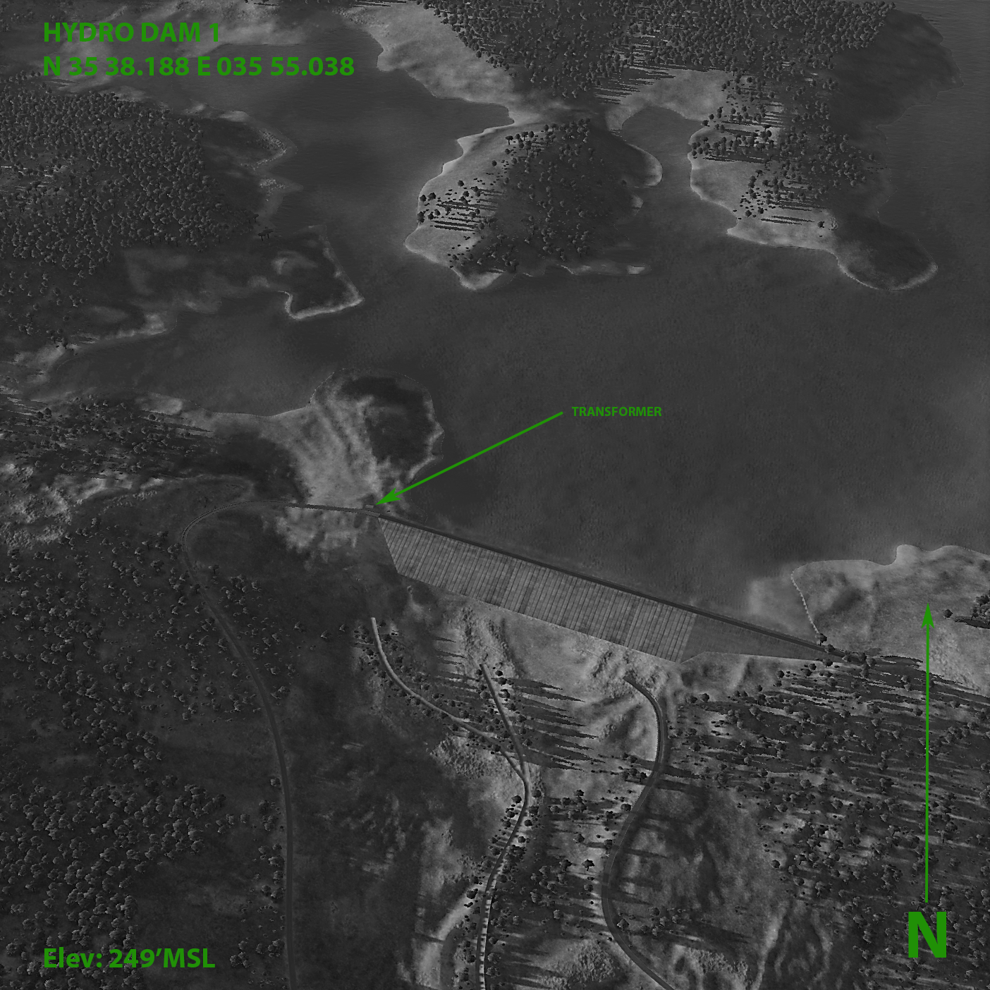

**HYDRO ELECTRIC DAM 1**

N 35 38.188 E 035 55.038

N35°38'1128 E035°55'0225

36S YE 64167 47549

Elev 249 ft

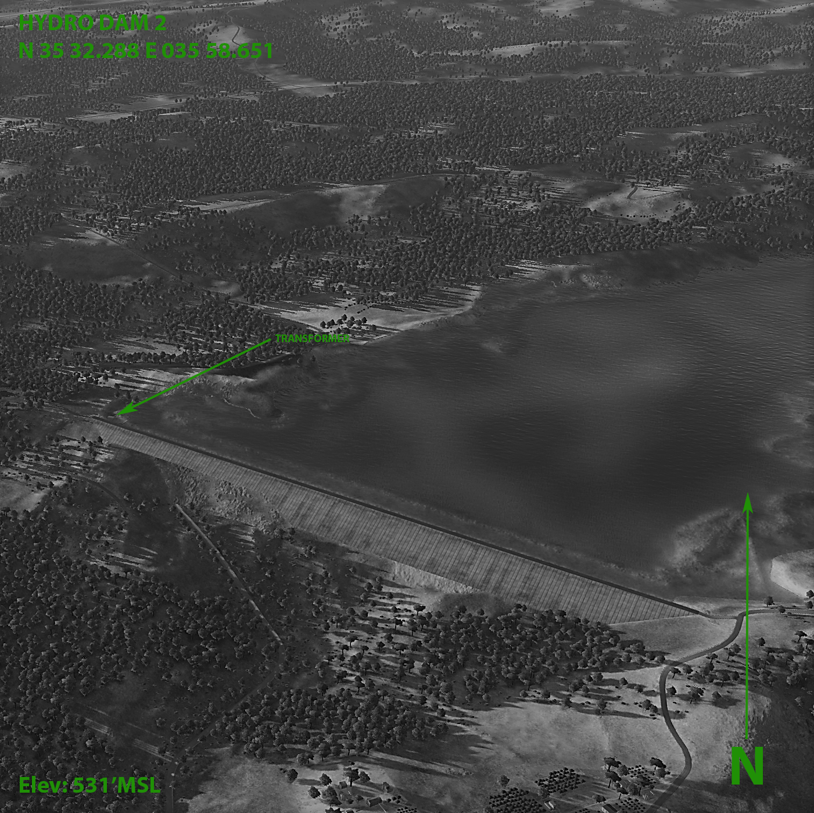

**HYDRO ELECTRIC DAM 2**

N 35 32.288 E 035 58.651

N35°32'1726 E035°58'3906

36S YE 69952 36801

Elev 531 ft

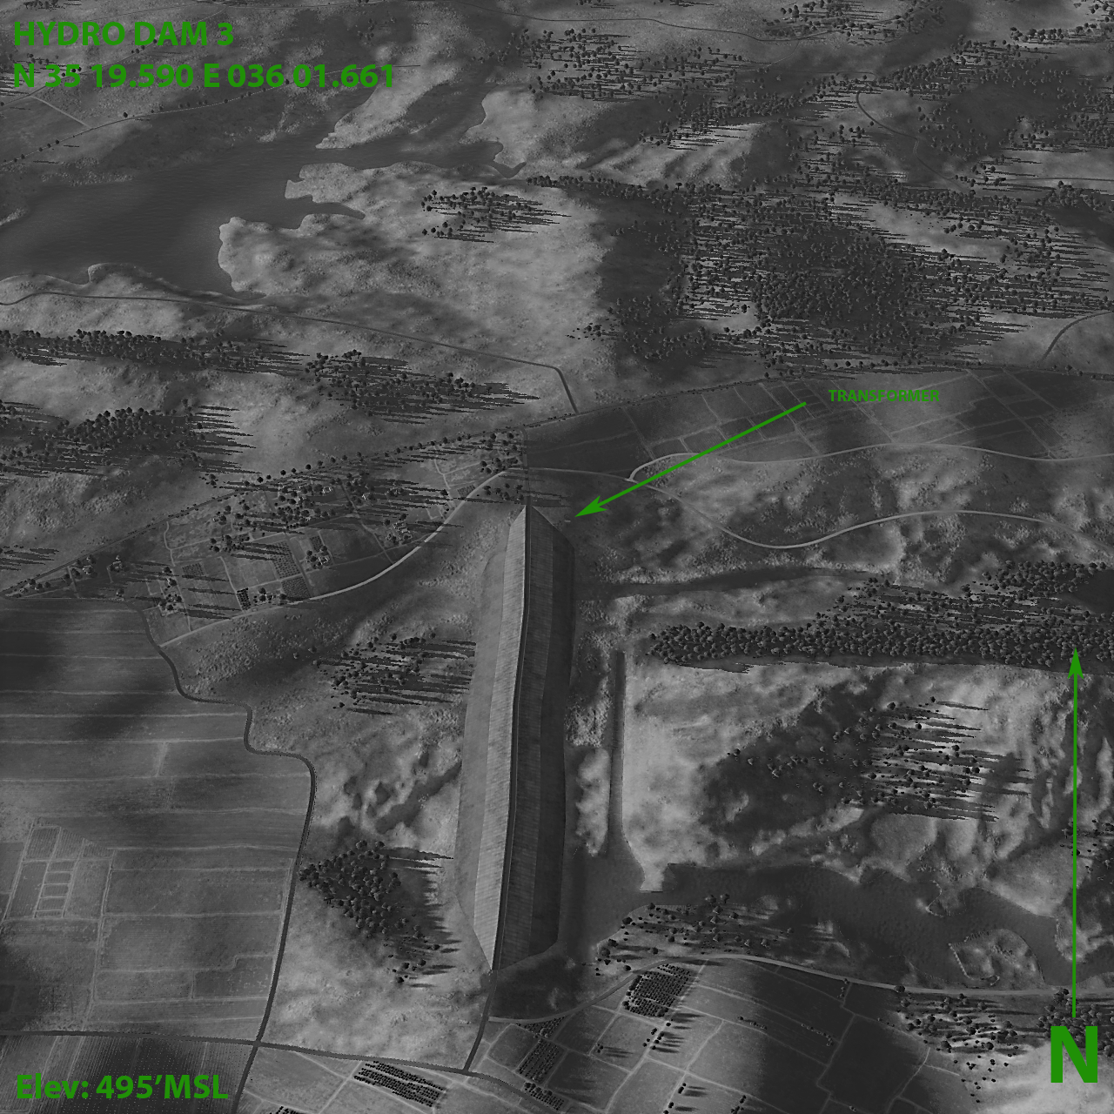

**HYDRO ELECTRIC DAM 3**

N 35 19.590 E 036 01.661

N35°19'3540 E036°01'3968

37S BV 29813 13306

Elev 495 ft

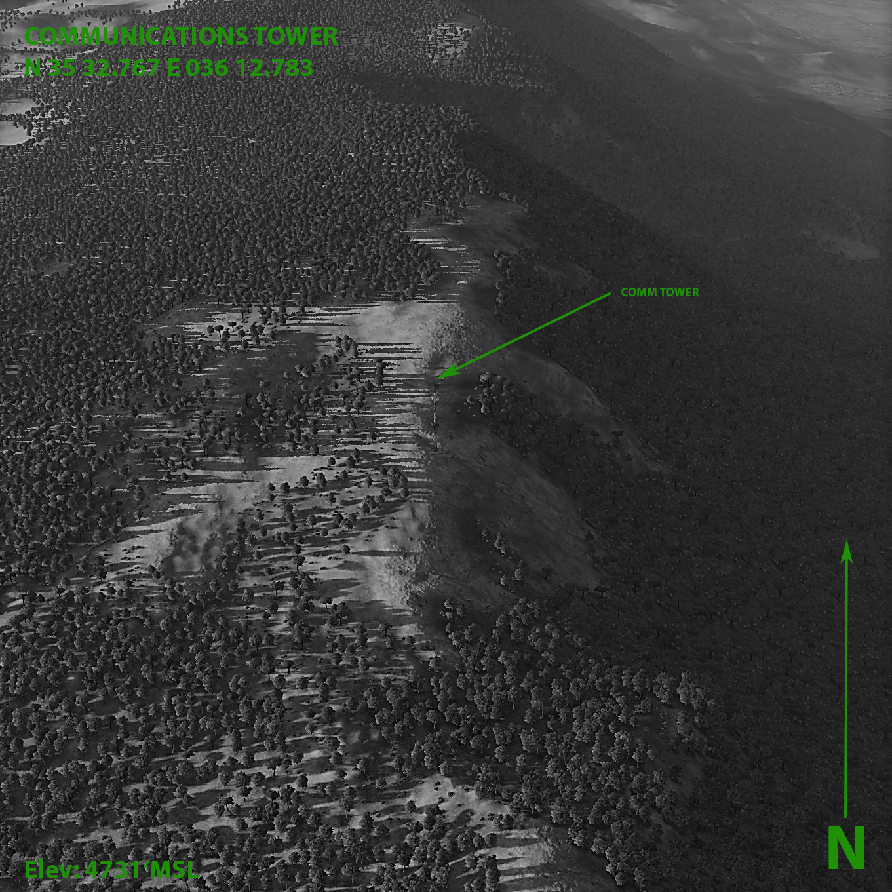

**COMMUNICATIONS TOWER**

N 35 32.767 E 036 12.783

N35°32'4601 E036°12'4700

37S BV 47355 37182

Elev 4731 ft

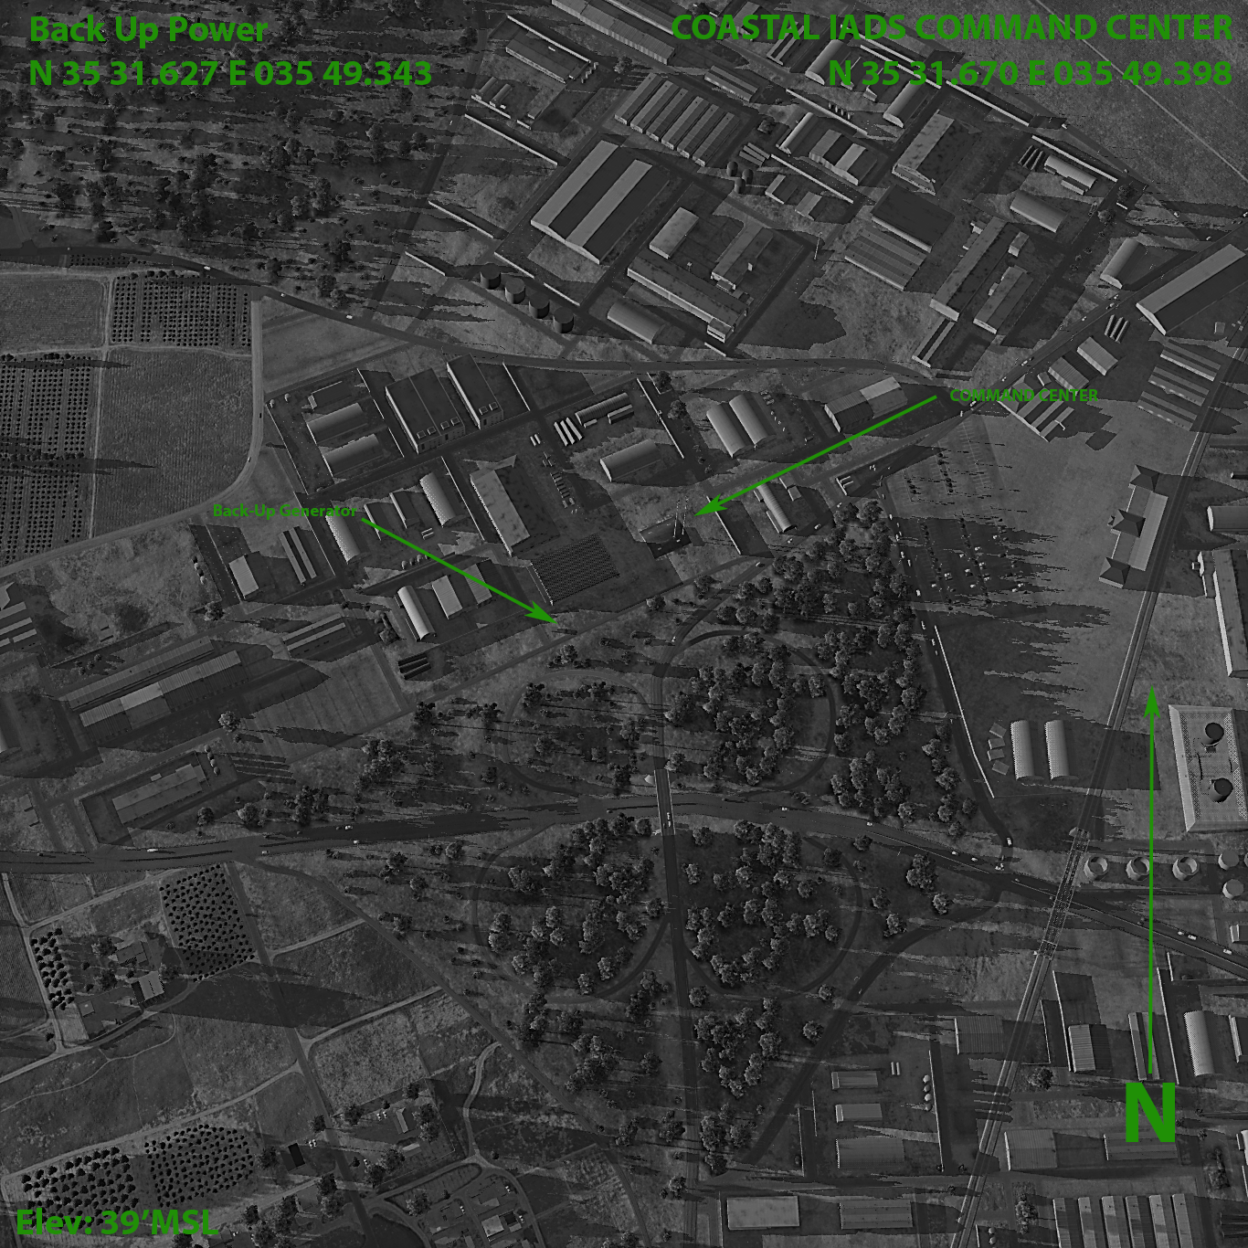

**COASTAL COMMAND**

N 35 31.670 E 035 49.398

N35°31'4019 E035°49'2388

36S YE 55999 35247

Elev 39 ft

**COASTAL COMMAND BACKUP POWER**

N 35 31.627 E 035 49.343

N35°31'3761 E035°49'2056

36S YE 55918 35165

Elev 39 ft

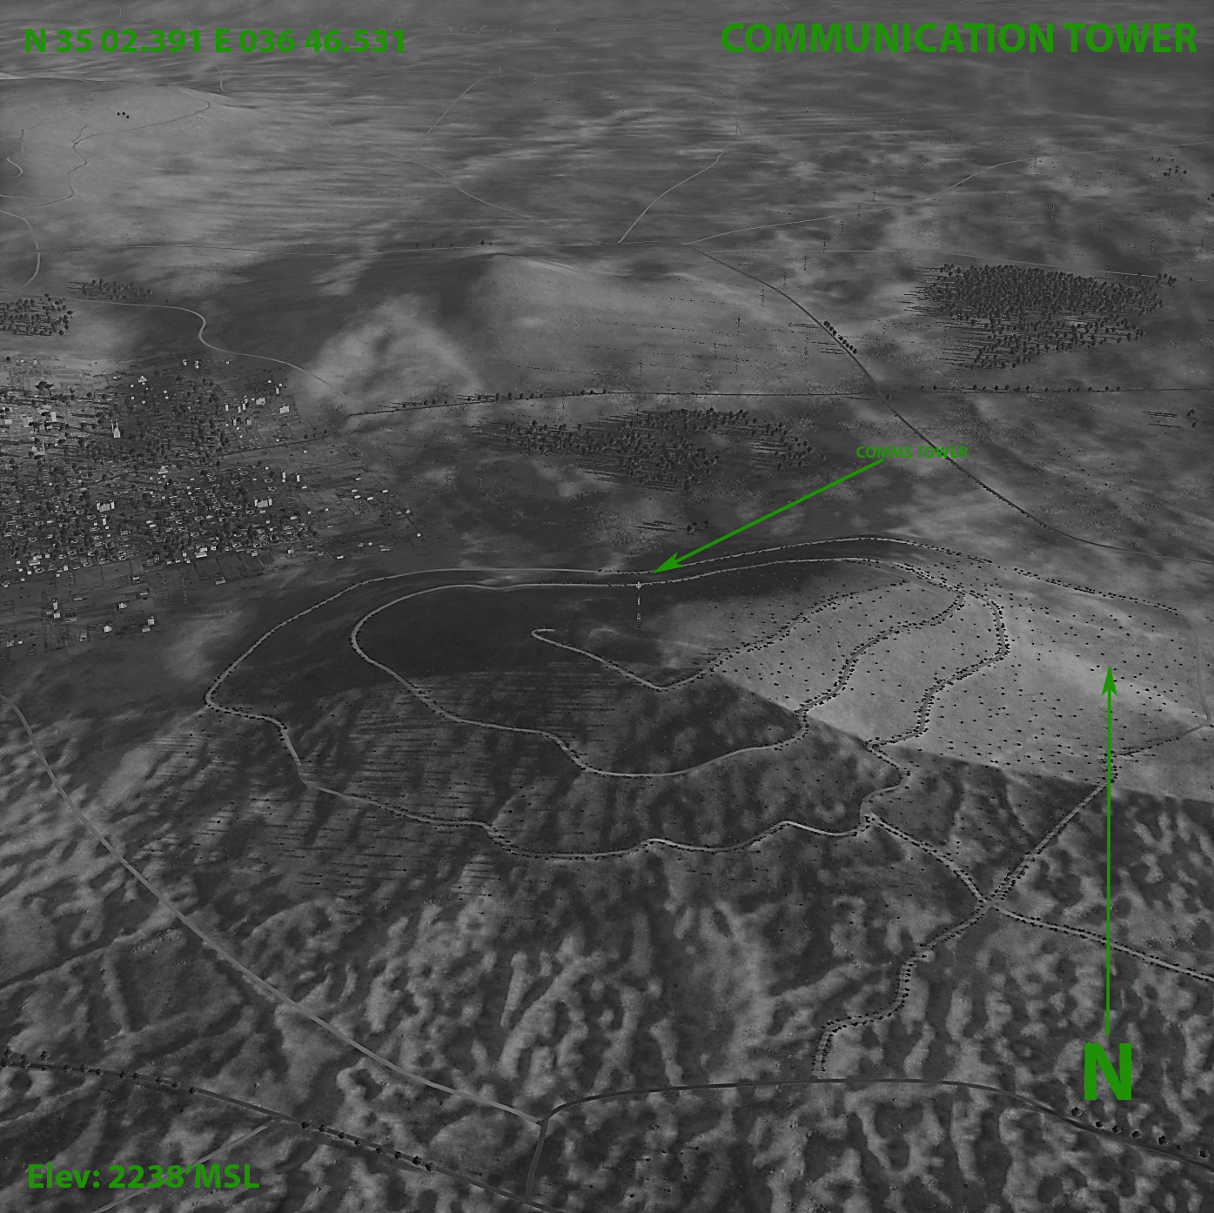

**COMMUNICATIONS TOWER**

N 35 02.391 E 036 46.531

N35°02'2348 E036°46'3186

37S BU 97093 79725

Elev 2238 ft

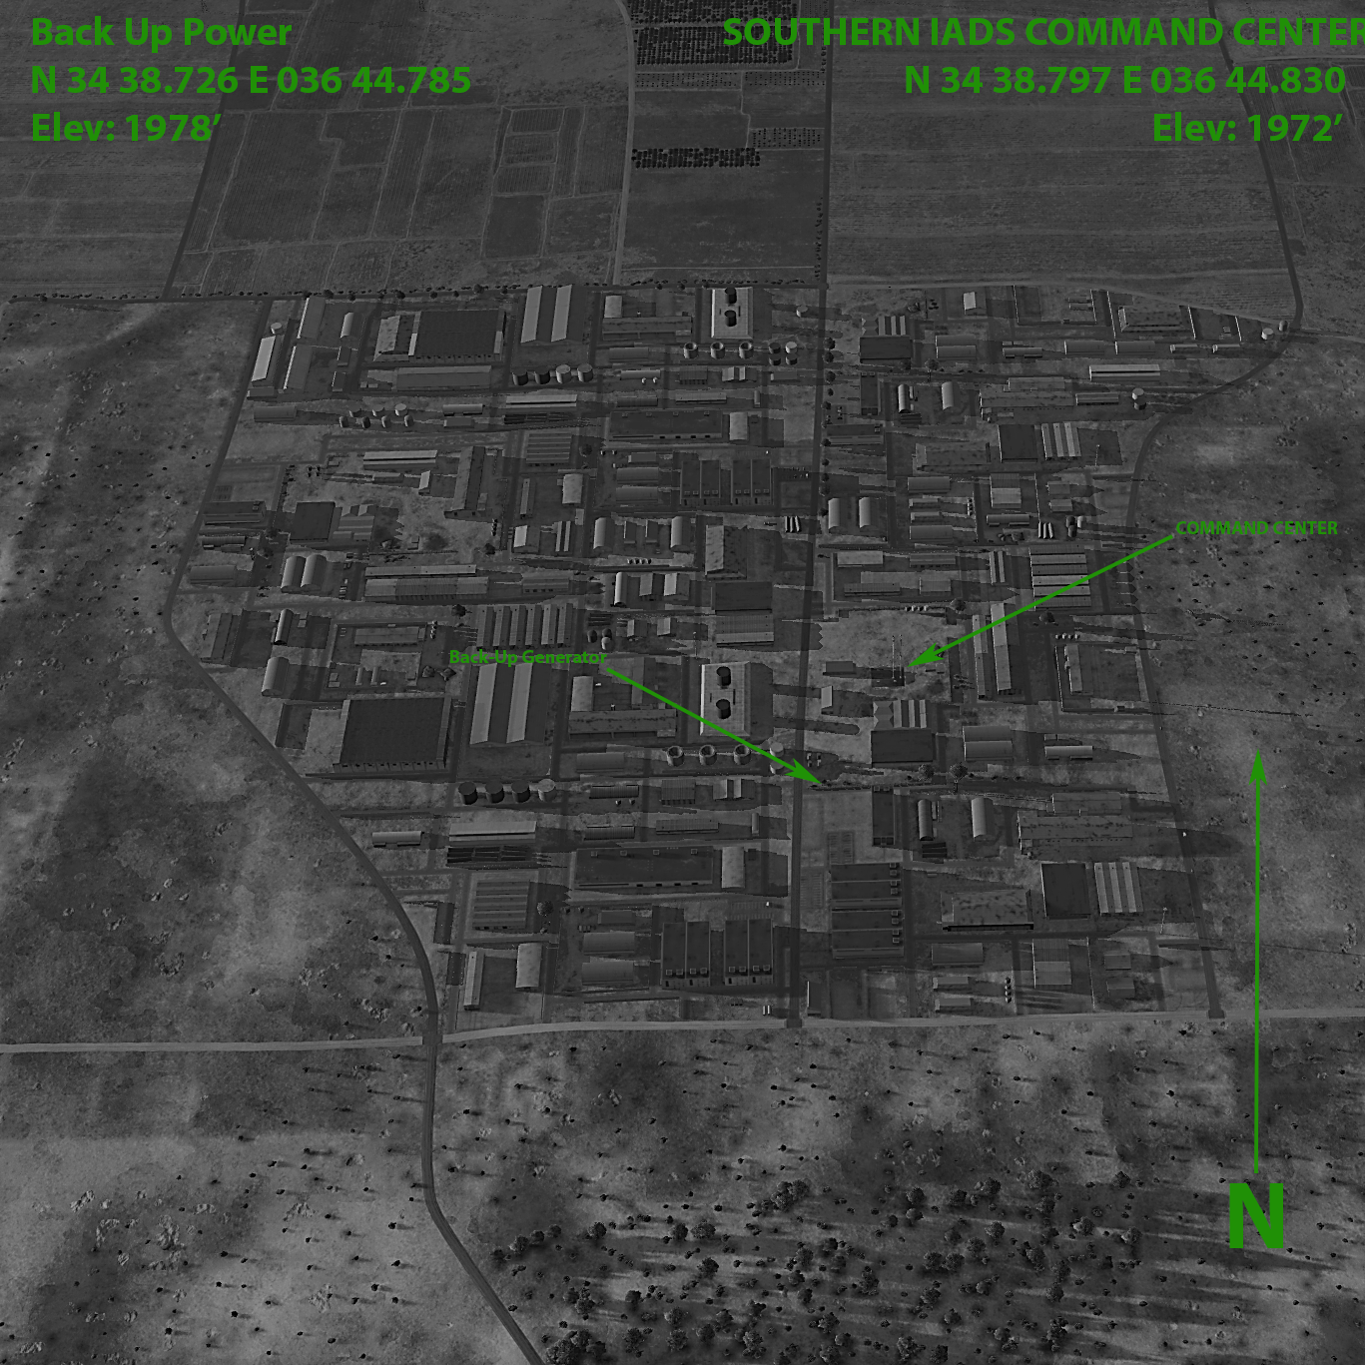

**SOUTHERN COMMAND**

N 34 38.797 E 036 44.830

N34°38'4780 E036°44'4980

37S BU 93526 36163

Elev 1972 ft

**SOUTHERN COMMAND BACKUP POWER**

N 34 38.726 E 036 44.785

N34°38'4353 E036°44'4707

37S BU 93454 36033

Elev 1978 ft

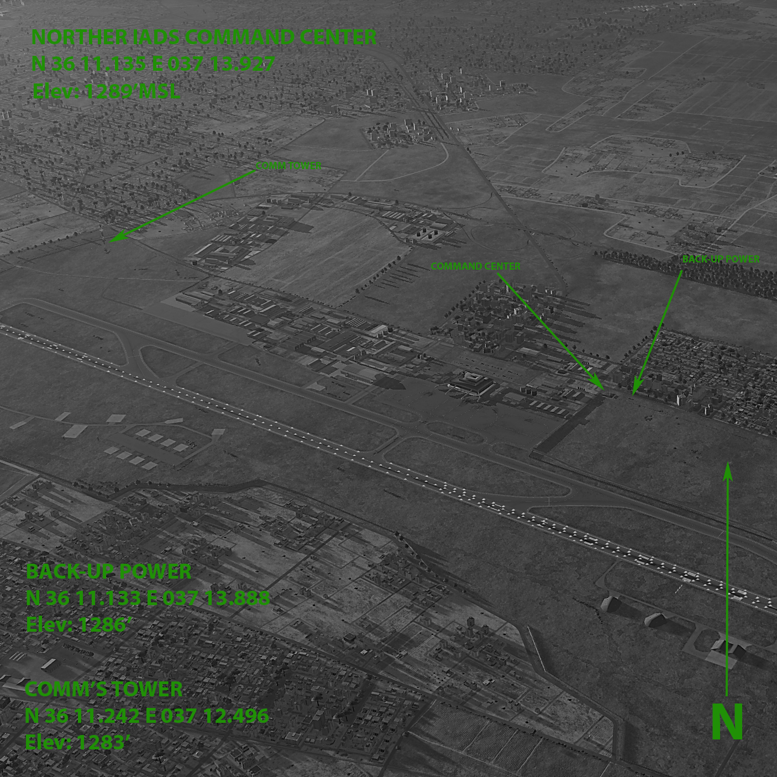

**COMMUNICATIONS TOWER**

N 36 11.242 E 037 12.496

N36°11'1449 E037°12'2976

37S CA 38890 06217

Elev 1283 ft

**NORTHERN COMMAND**

N 36 11.135 E 037 13.927

N36°11'0809 E037°13'5560

37S CA 41031 05981

Elev 1289 ft

**NORTHERN COMMAND BACKUP POWER**

N 36 11.133 E 037 13.888

N36°11'0800 E037°13'5326

37S CA 40972 05979

Elev 1286 ft

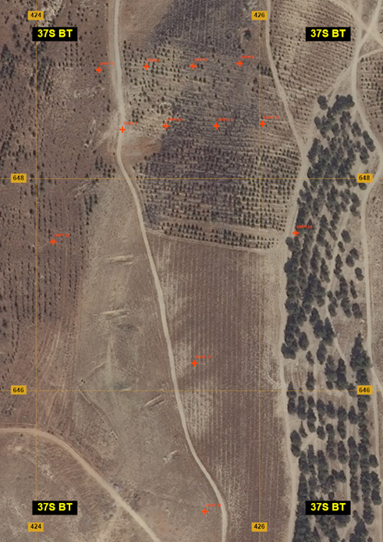**SA-10 Battery**

**DMPI_1**

**N 33 59.588 E 036 12.710**

**N33°59'3528 E036°12'4258**

**37S BT 42459 64900**

**Elev 3950 ft**

**DMPI_2**

**N 33 59.590 E 036 12.738**

**N33°59'3540 E036°12'4425**

**37S BT 42502 64902**

**Elev 3950 ft**

**DMPI_3**

**N 33 59.591 E 036 12.766**

**N33°59'3545 E036°12'4596**

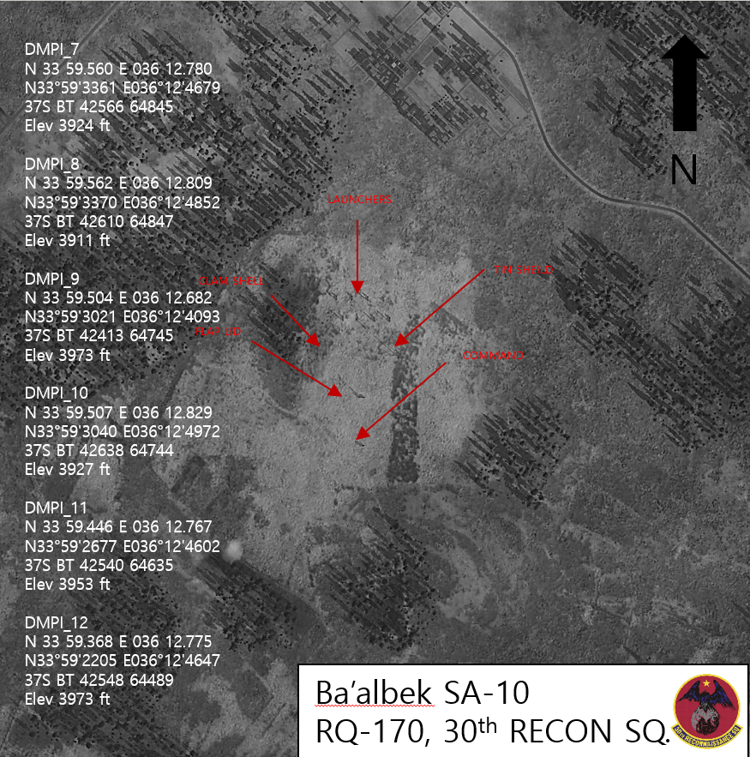**37S BT 42546 64903**

**Elev 3924 ft**

**DMPI_4**

**N 33 59.592 E 036 12.794**

**N33°59'3550 E036°12'4767**

**37S BT 42590 64903**

**Elev 3911 ft**

**DMPI_5**

**N 33 59.559 E 036 12.724**

**N33°59'3354 E036°12'4346**

**37S BT 42480 64845**

**Elev 3950 ft**

**DMPI_6**

**N 33 59.561 E 036 12.750**

**N33°59'3365 E036°12'4499**

**37S BT 42520 64848**

**Elev 3924 ft**

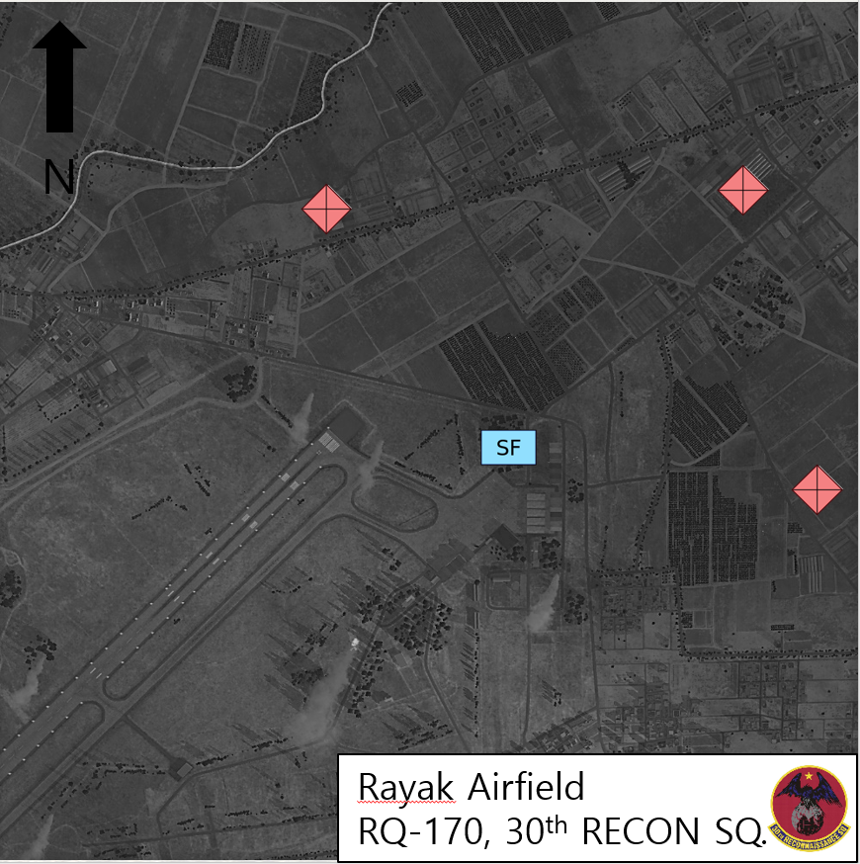

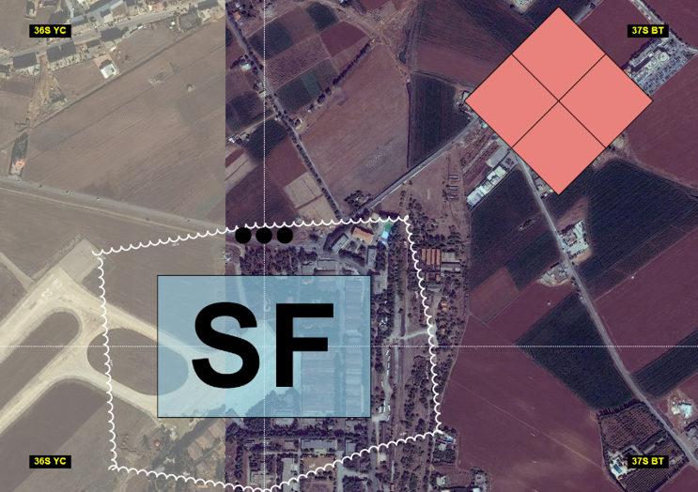

**Mission Specific Brevity**

A-10 hold point: Molson

F-16 SEAD mission complete: Kokanee

F-18 Precision strike mission complete: Samuel-Adams

Airspace/SA threats cleared: Budweiser

A-10/Helicopter ingress: Pilsner

LZ Secure: Pale-Ale

Commandos Extracted: Stout

Mission complete: Guinness